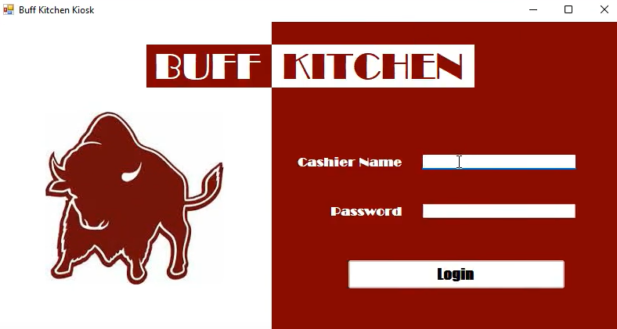

**Order Management Software Design Specification**

|  |
| --- |
| **Introduction**  The purpose of this project is to build a system to manage orders, customers and staff to ease restaurant management and processes. The restaurant currently has a Point of Sale system in place, and would like the new software to integrate with it and other existing systems for a cohesive management experience.  The software will need to be secure so that employee and customer information remains secure in the restaurant database, and so that payment information may be stored for returning customer use.  Ideally, the new software will provide a streamlined solution for restaurant management to easily and efficiently schedule employee shifts, manage all staff data, track current orders, keep track of customers data, and maintain their inventory all in one centralized location. By using one software for all needs, it will be easier to compile reporting for data analysis and business decisions.  The objectives of this project include a security component to protect stored data, integration with existing point of sale system used by the restaurant, payment processes, functionality to process and track customer orders, a customer relationship management component to store and track customer information and associated orders, inventory management in real-time, as well as the ability to transition to a mobile app for customers (and possibly staff). |
| **User Requirements**   * The system will provide customers the ability to place orders on a website and/or a mobile app, as well as processing payments from various methods, and tracking such orders in real-time. Customer information will be stored in a database for tracking and promotional purposes, with the ability to track orders by customer. Because of the sensitive nature of data stored, all data should be secure and reliable to protect customers, staff and management interests. Staff personal data, position duties and scheduling components will need to be added to the system for management to easily assign tasks for a set time period. The system will also manage restaurant inventory and provide real-time data to management for ordering purposes and alert them of inventory issues. Alerts will also be generated for any new orders, payment confirmations and specified concerns/issues as needed. The system functionality should be user-friendly and cohesively integrate with all existing systems. |
| **System Requirements**   * **Functional Requirements:**   + Security**:**     - System must use username-password authentication for login, possibly 2-factor-authentication to ensure customer personal and payment information is secure.   + System:     - Needs to easily integrate with existing systems, including Point of Sale (POS) system currently used. \***Need to identify specific existing systems with client.** POS will need to tie into new system for management of inventory, orders and payments.   + Order Processing:     - Online ordering capability     - System must be able to process various payment methods including, but not limited to, credit cards, Apple Pay, Google Pay, etc.     - Software should track orders in real-time, including confirmation number   + Customer Relationship Management:     - Store Customer personal data and tie to orders via confirmation number   + Inventory Management:     - Manage ingredients and inventory with real-time updates and editing capability.   + Employee Management:     - Store staff personal information     - Ability to assign staff to schedules and Compile restaurant schedule for all employees for a given timeframe. * **Non-Functional Requirements:**   + - Mobile ordering capability     - Estimated time of arrival for orders     - Track customer order history, special requests and allergies     - Ability to store payment data per customer profile     - Software should be user-friendly     - Efficient and effective order management     - Detailed reporting and analytics on sales, orders, customer data     - Identify job duties and tie to individual staff scheduling assignments.     - Software should send alerts to staff regarding new orders, payment confirmations and inventory issues. |